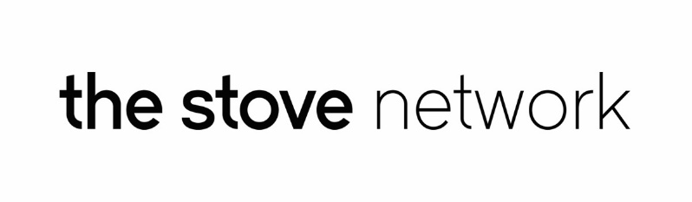
PRESS RELEASE
For immediate release 6th September 2016
Nithraid 2016 Celebrates Maritime History of Dumfries
September 3rd saw The Stove’s fourth staging of Nithraid, a fun family event that takes place on and around the river. The daring sailing race, starting from the Solway Firth and sailing right up to the River Nith in the centre of Dumfries, was made possible by one of the highest tides of the year. While waiting for the boats to arrive, visitors and families were invited over to The Mill Green to enjoy the ‘arts and food village’.
Matt Baker, lead artist on Nithraid, says, “With all the difficulties over flooding this year it was great to be celebrating the positive side of our beautiful River Nith again and showing the huge potential the riverside areas have as public spaces for locals and visitors alike. We were really pleased to have such a great turnout this year, despite the damp conditions. We would like to say a huge thanks to all those involved; our fantastic volunteer team, stall holders and workshop leaders, intrepid sailors and all those who braved the changeable weather.”
Nithraid is a celebration of the town’s long relationship with its river, highlighting the way the Nith connected Dumfries to the rest of the world through trade, goods (including Coos) and sailpower. It is created and produced by The Stove Network and is part of the groups mission to make creative opportunities for local people to be involved in the future of Dumfries. A total of 17 boats took part in the sailing race, with all boats carrying a small cargo which must be delivered into the town to complete the race. The winner - lone rower, Dave Golding - had the honour of lowering the legendary Salty Coo and releasing her into the river.
Visitors to Nithraid were treated to an afternoon of great local food and fun family activities. Local acoustic music acts played throughout the day, with acoustic competition winners Kate Kyle and Elia Davidson headlining. Internationally renowned artist Kathy Hinde hosted a music box migrations workshop, which explored the idea of using a picture as a musical score. Maklab Dumfries were also present with 3D printing, as well as MAK!; a team of Czech architects and artists currently touring Scotland in their mobile architecture studio camper van, who hosted a free drop in wooden motorbike making workshop. Stove team members also ran a pedal powered foundry tent, where visitors had the chance to get involved with making their own metal casting. Loch Arthur and Brambles Café also joined for the day, with a selection of local food produce, and Wee Sweetie Confectionary Creations were present to provide visitors with their Funky Floss creations.
A large crowd of people also joined in with the legendary Salty Coo procession, starting from The Stove on the High Street and finishing at the Mill Green, and were treated to this year’s other-worldly and extremely colourful procession! The Stove offers the opportunity for young artists to join the team to reinvent the Salty Coo Procession, and put their own stamp on part of the town’s cultural calendar. This year Dillon Colthart and Jordan Chisholm designed and created a very special procession on the theme of 'Acceptance'. Jordan and Dillon have both come up through the Electric Theatre Workshop in the town and are now studying for professional careers; Jordan in Glasgow and Dillon in London. Being inspired by such aspects as installation art, physical theatre and queer performance, they wanted to give something back to the river in a ritualistic, thought provoking and moving performance from the Midsteeple to Mill Green. Jordan said, “It is great mark of how things are progressing in Dumfries that students like Dillon and I can gain invaluable professional experience like this, in our home town, to complement our studies at college – there are not many of our fellow students who are getting breaks like this!” The Salty Coo procession commission is made possible through a special sponsorship deal with The Peoples Project who generously support many community projects in the town.

Sponsors for Nithraid 2016 included McDermid Supply Co. Ltd, Dumfries Timber Co, Monaghan’s Jewellery, Farries Kirk and McVean, People’s Project, Lowland Accountancy and Luke Moloney Architect.

End

Notes
The Stove Network is an artist-led organisation based in Dumfries and creating new activity and opportunities in the town centre based around The Stove, 100 High Street.
Contact: Matt Baker 07855 957401 matt@thestove.org

Nithraid
Nithraid is a fun family event that takes place on and around the river. Nithraid is a celebration of the town’s long relationship with its river, highlighting the way the Nith connected Dumfries to the rest of the world through trade, goods (including Coos) and sailpower. It is created and produced by The Stove Network and is part of the groups mission to make creative opportunities for local people to be involved in the future of Dumfries.

Contact: Mark Zygadlo 07759636534 mark@nithraid.co.uk

