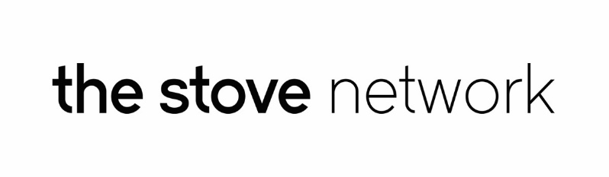

PRESS RELEASE
For immediate release 15th August 2016

Manga Madness at The Stove
The craze for Japanese comic book art hits Dumfries this week when ‘Moniaive Manga’ opens for a public preview night at The Stove on Thursday 18th August at 6pm. The exhibition features photography, cartoons and 3D printed busts, inspired by Manga and created at Moniaive Comic Festival earlier this summer.
Hairdresser Ralph Yates-Lee, photographer Kim Ayres and makeup artist Jade Jamieson worked collaboratively to create a series of images inspired by Manga at this year’s Moniaive Comic Festival, where 3 top cartoonists came along to draw the models as they were being photographed, and Maklab was invited to create 3D printed busts too. With all the work created in one inspired afternoon, the artists involved and The Stove dreamed up this exhibition to show what can happen when various creative minds work together.
Photographer Kim Ayres commented, “Being able to work on the Manga and Anime inspired images was the highlight of the Moniaive Comic Festival for me. There was a really fun and energetic atmosphere throughout the day, and it was a great opportunity to be able to work with a group of highly creative individuals. We wanted to bring that same level of creative energy and excitement into Dumfries town centre, and The Stove seemed like the obvious place to do so.”
On Tuesday 23rd August from 5pm – 7pm, photographer Kim Ayres, Hairdresser Ralph Yates-Lee and Makeup Artist Jade Jamieson will be discussing the advantages of collaborating with other creatives as part of blueprint100’s Open Tuesday sessions. Young, creative people and emerging artists under the age of 30 are welcome to join. For more information, please email Michael at bp100@thestove.org
The exhibition will run from Friday 19th August to Thursday September 1st, and will be displayed in The Stove Café.
End

Notes
The Stove Network is an artist-led organisation based in Dumfries and creating new activity and opportunities in the town centre based around The Stove, 100 High Street.

Contact Matt Baker 07855 957401 matt@thestove.org

