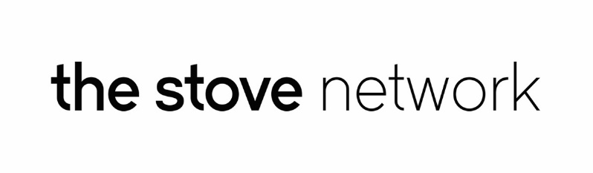
PRESS RELEASE
For immediate release 5th October 2016

Brave New Words Celebrated One Year Anniversary with Zine Launch
Brave New Words once again returned to The Stove, 100 High Street, on Friday 30th September, for a special night celebrating the first anniversary of this monthly platform for new writing, spoken and sung. The night consisted of an extraordinary mix of performance by local poets and songwriters, featuring film, music and a specially commissioned performance from local artists Michael Sullivan and Lee McQueen.

To celebrate their first birthday, Brave New Words teamed up with blueprint100 to create a special zine for the night. Supported by The Stove Network, Blueprint100, an emerging platform for artists under the age of 30, held various workshops throughout the month of September, in which previous participants of the open mic night submitted their original poetry and artwork to be part of the zine. The zine is currently available in The Stove Café for a small donation, with all proceeds going towards The Sindigo Foundation.

Martin O’Neill, who runs Brave New Words, commented, “The past year has been incredible, we’ve seen people grow more confident with each month, heard some of the most inspiring poetry and played host to dynamic people, workshops and ideas. We were really pleased with the amount of people that came along to be a part of Brave New Words, and we would like to thank all the participants for contributing, as well as anyone who picked up a zine and donated money.”

The open mic night is part of The Stove’s mission to bring vibrancy to evenings in the Town Centre. Through various performances, the event aims to challenge stigmas and stereotypes, whilst offering support to those willing to make a positive and impactful change in their home town and beyond. Over the past year, Brave New Words has held workshops with community groups, the general public and schools, in which they aim to celebrate diversity, and understand creative writing. They have also had the opportunity to host some of Scotland’s biggest names in the spoken word scene, voyaged to festivals, created multi-disciplinary installations and uncovered some incredible talent right here in the heart of Dumfries.

Brave New Words will return to The Stove on the 28th of this month for a special Halloween Spectacular open mic night.

To take part and for more information on events, please email martin@thestove.org.

End

Notes
The Stove Network is an artist-led organisation based in Dumfries and creating new activity and opportunities in the town centre based around The Stove, 100 High Street.

Contact: Martin Joseph O’Neill 07841 107742 martin@thestove.org
blueprint100 is supported by The Stove Network and made up of emerging artists and those interested in the arts between the ages of 16 and 30 years old. blueprint100 looks to create new opportunities for young people to develop a professional creative practice in the arts.
Contact: Michael Moore bp100@thestove.org

